**Brooklyn torah gazette**

**For parshas noach 5782**

Volume 6, Issue 3 (Whole Number 258) 3 Cheshvon 5782/ October 9, 2021

**Printed L’illuy nishmas Nechama bas R’ Noach, a”h**

For a free subscription, please forward your request to [***keren18@juno.com***](mailto:keren18@juno.com)

**Why Is There a Lincoln**

**Street in Jerusalem?**

**By Gedaliah Borvick**

[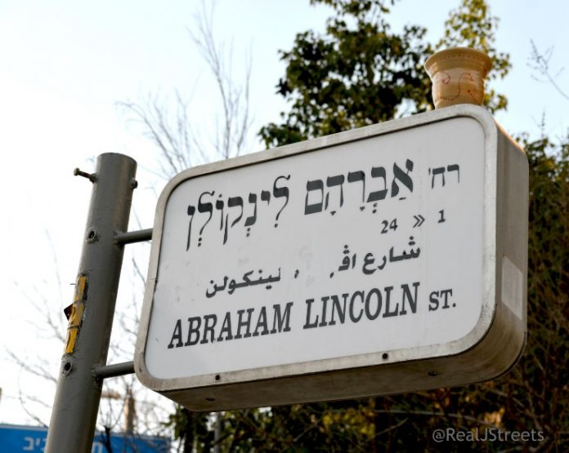](http://d16cunm4ue8a76.cloudfront.net/wp-content/uploads/2021/01/Borvick-Lincoln.jpg)**Lincoln Street, Jerusalem Photo Credit: Sharon Altshul of rjstreets.com**

I love the streets of Jerusalem whose inspiring names bring thousands of years of Jewish history to life. And yet, one of my favorite streets in central Jerusalem is named after Abraham Lincoln. Many years ago, while taking a taxi to a meeting on that block, I could not contain my smile when the cab driver pronounced the street name “Linc-o-lin” (his pronunciation was quite understandable because, in Hebrew, the second-to-last letter is a “lamed, and it includes nekudot on the street sign).

[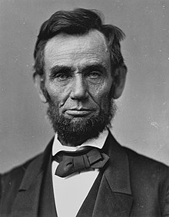](https://en.wikipedia.org/wiki/File:Abraham_Lincoln_O-77_matte_collodion_print.jpg)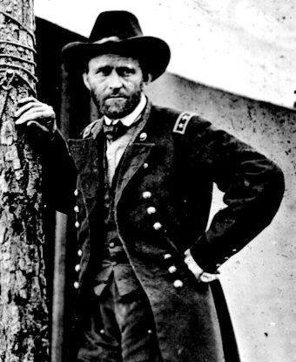

**Portrait of Lincoln by Alexander Gardner – November 1863 and photo of Ulysses S. Grant – June 1864**

Humorous Hebrew pronunciation aside, what did Lincoln do for the Jewish people to merit having a street named after him?

Arguably America’s greatest and most morally virtuous president, Abraham Lincoln is famous for abolishing slavery and granting legal equality to black Americans. Lesser known is the fact that Lincoln championed and defended the rights of Jewish Americans during a time period when it was difficult and unfashionable to do so. To Lincoln, eradicating persecution against blacks and Jews was synonymous, as one of his core principles, articulated in many of his speeches but immortalized in his monumental “Gettysburg Address,” was that “all men are created equal.”

Abraham Lincoln grew up in a religious household and his parents were members of the Calvinist Baptist Church, which, unlike most other churches during that time period, strongly opposed missionizing Jews. The anti-proselytizing environment of his youth left an indelible mark on Lincoln, helping foster his deep love of humanity and empowering him to include Jews in his diverse social network. Indeed, Lincoln’s valued friend, philosophical brother, and trusted confidant was a proud Jew named Abraham Jonas, which probably helped sensitize him to the repugnance of ethnic and religious prejudice.

During the Civil War, President Lincoln commissioned Jews to a broad variety of military and civilian leadership roles. For example, he appointed the army’s first Jewish military chaplains to serve the thousands of Jews fighting for the Union. However, his most famous public action was reversing a wartime order by the Union’s most successful general, Ulysses S. Grant, expelling Jews from areas under his control. The day after the order was revoked, a delegation of Jewish leaders traveled to Washington, D.C. to thank the president.

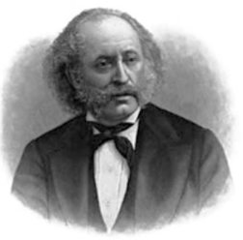

**Isaac Mayer Wise**

According to Isaac Mayer Wise, editor of The American Israelite newspaper, Lincoln assured his visitors that he knew “of no distinction between Jews and Gentile.” Rebuking Grant, whose mistrust of the Jews unfortunately reflected the general feelings of society towards the immigrant population, which had ballooned from 3,000 in the early 1800s to more than 150,000 by 1865, Lincoln didn’t mince words in stating that “to condemn a class is, to say the least, to wrong the good with the bad. I do not like to hear a class or nationality condemned on account of a few sinners.”

Abraham Lincoln mentioned to his wife on the afternoon before he was tragically assassinated that, after completion of his second term in office, they should travel to Europe and Palestine, expressing a desire to see Jerusalem before he died. Perhaps naming a street in Jerusalem fulfills Abraham Lincoln’s unrealized wish. Or perhaps it merely reflects American Jewry’s tremendous gratitude to Lincoln who, as Jonathan Sarna in Lincoln and the Jews eloquently wrote, “promoted the inclusion of Jews into the fabric of American life and helped to transform Jews from outsiders in America to insiders.”

Jonathan D. Sarna and Benjamin Shapell’s groundbreaking historical book, “Lincoln and the Jews,” was the primary resource for this article.

Gedaliah Borvick is the founder of [*My Israel Home*](http://myisraelhome.com/), a real-estate agency focused on helping people from abroad buy and sell homes in Israel. To sign up for his monthly market updates, contact him at [*gborvick@gmail.com*](mailto:gborvick@gmail.com).

Reprinted from the January 6, 2021 website of Larry Gordon’s 5TJT (Five Towns Jewish Times).

**Parshas Noach:**

**HASHEM Hates Thievery**

**By Rabbi Bentzion Shafier**

**Founder of TheSmuz.com**



“*And HASHEM said to Noach, “The end of all flesh has come before me since the land is filled with robbery through them, and I will now destroy the land*.” – Bereishis 6:13

**The World Turned to Iniquity**

In this *posuk*, HASHEM appears to Noach, telling him that the world has turned to evil and He will now destroy all of life. Noach, his family, and the animals that remained pure will be the core of a new world. The reason for this destruction is stealing: “*since the land is filled with robbery.*”

Rashi is troubled that thievery is being treated as the pivotal point of the world’s existence. There are many sins that are worse. Rashi seems to answer this by saying that stealing was the crime that sealed their fate. Granted they were involved in other iniquities, but this was the one that actually demanded justice.

This Rashi is difficult to understand. as we know that stealing is not one of the most severe sins. There are three cardinal sins that a Jew is obligated to give up his life not to commit: **idol worship**, **adultery**, and **murder**. While stealing is certainly a serious crime, it isn’t amongst these. – in fact, it isn’t even in their league. If so, why would this be the reason that spelled the doom of that generation?

And even more to the point, in a previous *posuk*, Rashi told us that the main crimes then were idol worship and illicit relations. The Torah tells us “*all flesh was corrupted*.” Rashi explains that (Because of man’s immorality) “even the animals changed their ways and were mating outside of their own species.” It is clear that these more serious sins were rampant. How then can we understand Rashi’s statement that *stealing* was the crime that caused their destruction?

This question can best be answered with a *moshol*.

**Different Scales of Measure**

Bangladesh is one of the poorest countries on the planet; the average working man there earns about 180 dollars a year. Imagine that I walk into a Savings and Loan Company in the United States and say, “I am looking to take out a mortgage on a new home.”

The loan officer will ask me, “What is your income? What assets do you have?”

I respond, “My friend, no need to worry. Why, I earn as much as ten men in Bangladesh. In fact, I don’t like to brag, but actually, I earn as much as hundred men there!”

Needless to say, I wouldn’t secure a loan. Because earning 1,800 dollars a year or even 18,000 dollars a year in our economy is below poverty level.

This is an example of different scales of measure. In a third world country where much of the population is starving, earning your daily bread and water might qualify you as well off, whereas in a more affluent world, it would be quite poor. More than objective wealth being the determinant of your status, it is the standard against which you are being measured. When the bar is raised, it becomes much more difficult to be considered acceptable.

So too, in the system of HASHEM’s judgment, there are different standards of measure. There is *din* – strict judgment – and there is *rachamim* – the mercy system. Strict *din* demands perfection. There is no room for shortcomings and no place for excuses; you are responsible. You did an act that act that brought about a result, so you are accountable-- Utterly, completely and totally. No mitigating factors, no extenuating circumstances, you are guilty as charged.

*Rachamim* is very different. This system introduces understanding: “there were compelling factors.” “It was a difficult situation”. “There are few people in this generation who would have done much better”…

In the Heavenly system of judgment, there is a balance between *rachamim* and *din*. At one point, the balance may be 60% *rachamim*, 40% *din*. At another point it might be 80/20. If strict *din* would be in place, no mortal could stand. Even the Avos, the greatest humans who ever lived, would not have passed.

Certain times and actions change the balance between *rachamim* and *din*. Much of our *davening* focuses on asking HASHEM to judge us more favorably, to introduce mercy into the deliberation. On the flip side, there are certain actions that strengthen the *middah* of *din*, moving the balance over to more strict judgment.

***When Din is in Force***

This seems to be the answer to Rashi. It isn’t that stealing is a more severe crime than immorality — it is less severe. However, there is an element to stealing that awakens *din*. Stealing from a person demonstrates a total disregard of his rights — it as if he isn’t a person. I can take away his property, even his very sustenance. Chazal tell us, “As a person acts towards others, HASHEM acts towards him.” Because robbery is an abrogation of a person’s rights, it causes a change in the way that HASHEM judges. It is as if HASHEM says, “If you act that way towards others, then I will act accordingly to you.” Therefore, stealing changes the way that HASHEM judges because it causes the *middah* of *din* to react more strongly.

The other sins that the generation were involved in had much more serious consequences, but they didn’t include a lack of respect for others, and therefore didn’t carry this element of changing the system of judgment. It was stealing alone that sealed their fate because it changed the system of judgment.

**Living in the 21st Century**

This concept is especially applicable in our times. Never before in the history of humanity has so much wealth been accessible to so many. Kings of yesteryear could not envision or imagine the luxuries that the common man today takes for granted. Yet it seems to be more difficult than ever to earn a living. The great test of life is not earning a living; but *how* you earn your living. Are you honest? Are you scrupulous? Do you have standards and immutable rules?

While the primary motivation for honesty in business is that it is the right way to act, this Chazal demonstrates to us another reason: it changes the way that HASHEM acts towards us. It would be difficult to imagine the man who can say to HASHEM, “I am entitled to earn a living! Based on my calculations of what You have given me and what I have done for You, You owe me.”

Therefore, it is ill-advised for a person to enter into “calculations with HASHEM,” demanding his needs. Far wiser is the man who recognizes that we exist because of mercy. Before HASHEM creates us, we do nothing to deserve being created, and after HASHEM creates us, we aren’t any different. We depend upon HASHEM’s mercy.

If we wish to gain favor in HASHEM’s eyes, then we need to utilize the systems that He has created. By respecting other people and being scrupulously honest in our business dealings, we make it far more likely for Him to judge us with mercy and take care of us, His beloved people.

*Reprinted from the current website of TheShmuz.com*

# Rav Avigdor Miller

# On Staying Married

**QUESTION:** **Should a woman have to suffer from a husband who’s a boor?**

**ANSWER:** Once you’re married, you have to make the best of it. Look, maybe you’re the one who is to blame more than your husband. Whatever it is, you look before you leap but once you leaped, then stay where you are. And live your whole life satisfactorily. You’ll get schar, you get reward for that.

This idea of being dissatisfied always, of always wanting something else is a tragedy. The world today is in motion, in disturbance, and there are so many divorces. Every divorce is a tragedy; it’s a Churban Bais Hamikdosh to ruin a Jewish home. And therefore, no matter whom you marry, as long as he’s a shomer mitzvos and he’s working to support the family, then you should make it your business to be loyal to him and stay together. You’ll marry off your grandchildren together and you’ll have nachas.



Don’t make any fuss; don’t say, “I want to leave him” or “I should have had a better husband,” or “a more affectionate husband,” or “a bigger lamdan.” Forget about it. Don’t look for faults in him. The one you married, that’s the one you should stay with.

**QUESTION:** **So you’re saying a woman stay with her husband no matter what?**

**ANSWER**: Yes! If he works. He has to work. If he doesn’t work, it’s a very big problem. He has to work to make a living. It’s his duty to work. It says openly in the kesubah, אנא אפלח – “I’m going to work and support you.” That’s his job to do. And he has to be a shomer mitzvos too.

*Reprinted from the September 2, 2021 email of Toras Avigdor (Tape #E-234.)*

**Rabbi Berel Wein on**

**Parshat Noach 5782**



The ten generations described in the Torah, from Adam until Noach, produced only chaos and eventual destruction. There were a few individuals, such as Chanoch, who were moral and positive people. However, they had little, if any, influence on the general society in which they lived, and not even one person who would follow them and their moral behavior.

Our world, and all our societies are, to a great extent, copycat structures of those days. The general excuse for all immoral behavior from childhood is the expression "everyone is doing it". Somehow, this excuse, that everyone is doing it, removes responsibility from any individual who engages in any immoral activity. Thus, there develops a chain of almost never-ending failure, excuses, and willingness to accept bad behavior as a societal norm.

The ten generations that led up to the coming of the Great Flood sank into this morass of evil without realizing it. They were merely repeating the actions of the generations before them, and what they saw was everyone else behaving in a similar fashion. Evil and immoral behavior are very easily accepted in general and mass society. This notion explains Nazism in Germany and Stalinism in the Soviet Union. It also helps describe much of what is transpiring in Western society today.

The slow erosion of morality, good behavior and godly faith is a constant challenge to all societies, and if no one stands up against it, those societies are eventually doomed to their own self-destruction.

In the eyes of Jewish scholarship and tradition, Noach is found wanting, not so much for his own personal failings after the Flood, but, rather, for his inability to stand against the evil in his society. He builds an ark and warns against the impending disaster that is about to befall the human race. However, he is unable to identify evil for what it is, and to declare a viable alternative for human beings to adopt and follow. There is a feeling of hopelessness that seems to envelop him and his actions, and he fails in building a new world because of the belief that "everyone does it" is a sufficient excuse for bad behavior and human immorality.

It is because of this that Midrash and Jewish tradition generally view Noach and his righteousness with a fair degree of skepticism. His planting of the vineyard as his first project after emerging from the ark is an example of the acceptance of the idea that if everyone does it, then, somehow, it can be justified and even lauded. It is almost painful to read in the Torah how Noach fails to remake the world after the Flood in a better image and a more positive vein.

The Torah illustrates for us that great people can have great failings, and that lost opportunities will always come back to haunt us and frustrate human progress. We are all the descendants of Noach, and his character traits exist within our personal DNA even millennia later. We will have to wait for the arrival of Abraham and Sarah to put us on a better and more upward trajectory of belief and behavior.

*Reprinted from the current website of rabbiwein.com*

**An Important Lesson to be Learned from the Life of Noach**

**From the Talks of the Lubavitcher Rebbe**

**Rabbi Menachem Mendel Schneerson, Zt”l**



This week's Torah portion, Noach, begins with G-d's description of Noach [Noah]: "Noach was a righteous man, perfect in his generation." Even though Noach lived in a generation of sinful individuals, he nonetheless merited to receive this praiseworthy description from G-d.

Noach was the only member of his generation who behaved properly; the conduct of everyone else living at that time was depraved. But Noach was not ashamed of acting differently. He served G-d in an open manner

**An Entire New World was Created by Noach.**

In the merit of his exemplary behavior, Noach and his family survived the Great Flood while all others perished. Indeed, it was Noach and his children who re-populated the world and through whom mankind continues to exist. An entirely "new world" was established by Noach, as it were.

In truth, Noach's conduct contains a valuable teaching for every Jew. It sometimes happens that a Jew may want to learn Torah with great diligence, but the yetzer hara (evil inclination) intervenes. "Look around you," the yetzer hara stops him. "No one else takes his studies so seriously. Why must you be different from everyone else? Better you should close your books and do something else."

Or, one may want to observe a particular mitzva, but the evil inclination whispers: "Take a good look around! Do you see anyone else doing this mitzva? You shouldn't do it, either."

**The Ways of the Evil Inclination**

There are many instances in which the evil inclination tries to stop a Jew from doing a mitzva. Why, the entire world is filled with billions of people, and most of them are behaving in an entirely different fashion! How can you, a single and solitary individual, announce to the entire world (by doing that mitzva) that all of creation belongs to G-d? Why should you be different and recite a verse from Torah stating that "In the beginning G-d created the heavens and the earth"?

The arguments of the evil inclination must be answered by following Noach's example.

**The Jew Must Learn from Noach’s Behavior**

Just as Noach disregarded his surroundings, so too must every Jew pay no attention to the conduct of friends and colleagues when it is not in accordance with the teachings of the Torah. And just as Noach succeeded in his path, which was different from the rest of society's so too, will every Jew succeed in conquering his yetzer hara, allowing him to learn Torah and observe mitzvot even in a hostile environment.

After the Flood, Noach merited to establish a new world. Similarly, every Jew has the power to save an entire world and bring redemption with "Moshiach Now!"

*Reprinted from the 5756/1996 Parshat Noach edition of L’Chaim Weekly. Adapted from an address of the Lubavitcher Rebbe to Tzviso Hashem (a youth group) in 5743/1983).*

**Thoughts that Count**

"*And from the animals which were not clean [kosher*]." (Gen. 7:8)

The Talmud (Pesachim 3a) asks why the Torah uses the longer expression "which were not clean" (three words in Hebrew) instead of the briefer word "ha'tameah"-- "unclean" (only one word in Hebrew). The Talmud answers that the Torah uses additional words to teach us the eternal lesson that we should always try to express ourselves in decent language, even if it means using extra words.

"*They and all the animals [were in the Ark]*." (Gen. 7:14)

The prophet Isaiah includes in the miraculous events of the days of Moshiach that "the wolf will dwell together with the lamb" (11:6). This was also experienced in the days of Noach. What, then, is so unique about the days of Moshiach? In the time of Noach, the whole world was in danger of destruction and annihilation. In such a situation it is natural for enemies to become friends and live together. All had the common goal of survival and there was no time for fighting.

In the days of Moshiach, there will no longer be any war and there will be an abundance of goodness. Unfortunately, in prosperous and tranquil times, people find time for strife and fighting. Isaiah therefore foretells the miracle that will occur in the days of Moshiach, when everyone will have an abundance of good: even then there will be absolute peace and the wolf and lamb will abide together.

"*Only Noach survived*." (Gen. 7:23)

Why is he described here as "only Noach"? What happened to the previous titles the Torah gives him--"righteous," "perfect," etc.? The Zohar says that Noach sinned by not praying that his generation be saved, unlike Avraham and Moshe. Moshe was even ready to give up his own life if G-d would not forgive His people, Noach was concerned only that his own family be saved. Since Noach did not ultimately act as a truly righteous man by concerning himself with others, he was considered in the final analysis "only Noach"--just a simple person shorn of all his titles and praises.

*Reprinted from Reprinted from the 5756/1996 Parshat Noach edition of L’Chaim Weekly. Excerpted from Vedibarta Bam, compiled by Rabbi Moshe Bogomilsky*

**An Associated Press (AP) Photo of a Pidyon Haben Ceremony in Israel**

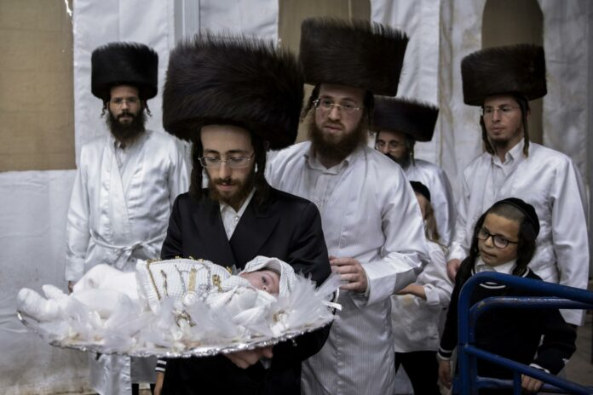 Rabbi Yaakov Tabersky, carries his 30-day-old son Yossef, the great grandchild of the chief rabbi of the Lelov Hassidic dynasty, during the "Pidyon Haben" ceremony in Beit Shemesh, Israel, Thursday, Sept. 16, 2021. (AP Photo/Oded Balilty)

This photo taken by the Associated Press new service’s chief Israeli photographer Oded Balilty and was distributed to thousands of member newspapers primarily throughout the United States for possible publication along with a story about the traditional Jewish ritual of redeeming the first-born son.